%oef8.1

%initiele condities

y0=[1.0 0.1 0 0];

%tijdsduur

tspan=[0 1000];

%solver oproepen

[t y]=ode45(@oef8.1f,tspan,y0);

%resultaat plotten

plot(t,y(:,1),'b:',t,y(:,2),'r-',t,y(:,3),'g-',t,y(:,4),'k-')

xlabel('Tijd (s)')

ylabel('Concentratie (kg/m^3)')

legend('Substraat', 'Enzym', 'Intermediar','Product')

title('Enzymkinetiek')

function [ ydot ] = oef8f( t,y )

k1=0.1;

k1rev=0.1;

k2=0.05;

S=y(1);

E=y(2);

ES=y(3);

P=y(4);

ydot=[-k1*S*E+k1rev*ES

-k1*S*E+k1rev*ES+k2*ES

k1*S*E-k2*ES-k1rev*ES

k2*ES];

end

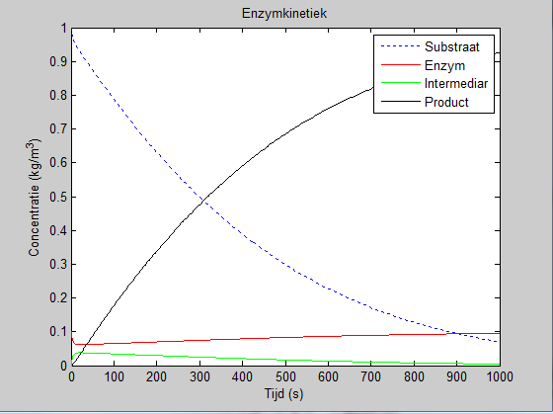

%oef8.2

%initiele condities

y0=[1.0 0.1 0 0];

%tijdsduur

tspan=[0 1000];

%solver oproepen

[t y]=ode45(@oef8_2f,tspan,y0);

%resultaat plotten

plot(t,y(:,1),'b:',t,y(:,2),'r-',t,y(:,3),'g-',t,y(:,4),'k-')

xlabel('Tijd (s)')

ylabel('Concentratie (kg/m^3)')

legend('Substraat', 'Enzym', 'Intermediar','Product')

title('Quasi-steady state')

function [ ydot ] = oef8_2f( t,y )

k1=0.1;

k1rev=0.1;

k2=0.05;

E0=0.1;

S=y(1);

E=y(2);

ES=y(3);

P=y(4);

ydot=[-k2*E0*(S/(((k1+k2)/k1)+S))

-k1*S*E+k1rev*ES+k2*ES

0

k2*ES];

end

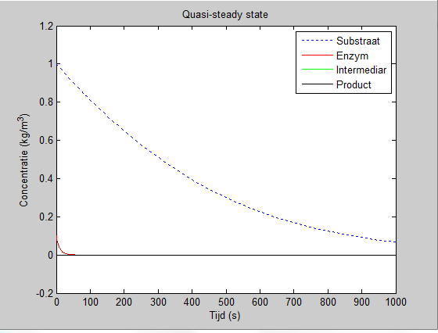

%oef8.3

%initiele condities

y0=[1.0 0.1 0 0];

%tijdsduur

tspan=[0 1000];

%solver oproepen

[t y]=ode45(@oef8_3f,tspan,y0);

%resultaat plotten

plot(t,y(:,1),'b:',t,y(:,2),'r-',t,y(:,3),'g-',t,y(:,4),'k-')

xlabel('Tijd (s)')

ylabel('Concentratie (kg/m^3)')

legend('Substraat', 'Enzym', 'Intermediar','Product')

title('Michaelis-Menten-Model')

function [ ydot ] = oef8_3f( t,y )

k1=0.1;

k1rev=0.1;

k2=0.05;

S=y(1);

E=y(2);

ES=y(3);

P=y(4);

E0=0.1;

vmax=k2*E0;

kd=0.001;

Km=(k1rev+k2)/k1;

ydot=[(-vmax*(exp(-kd*t))*S/(Km+S))

-k1*S*E+k1rev*ES+k2*ES

k1*S*E-k2*ES-k1rev*ES

k2*ES];

end

